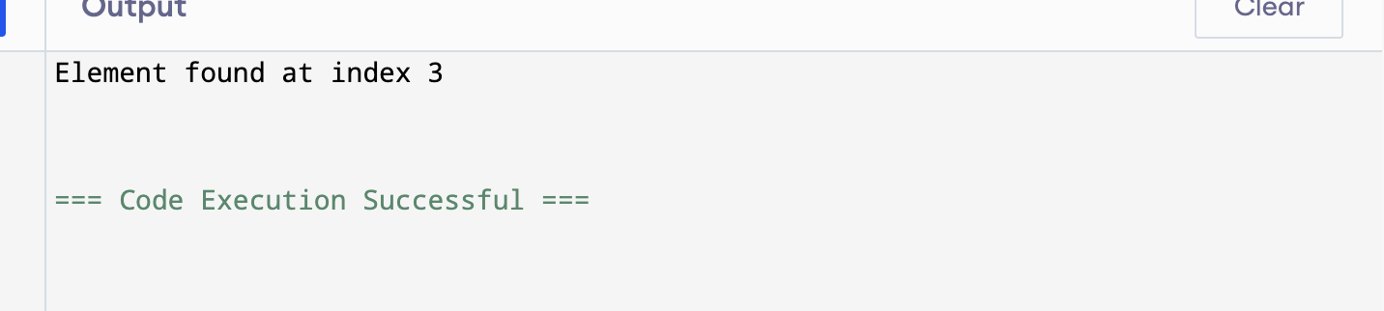

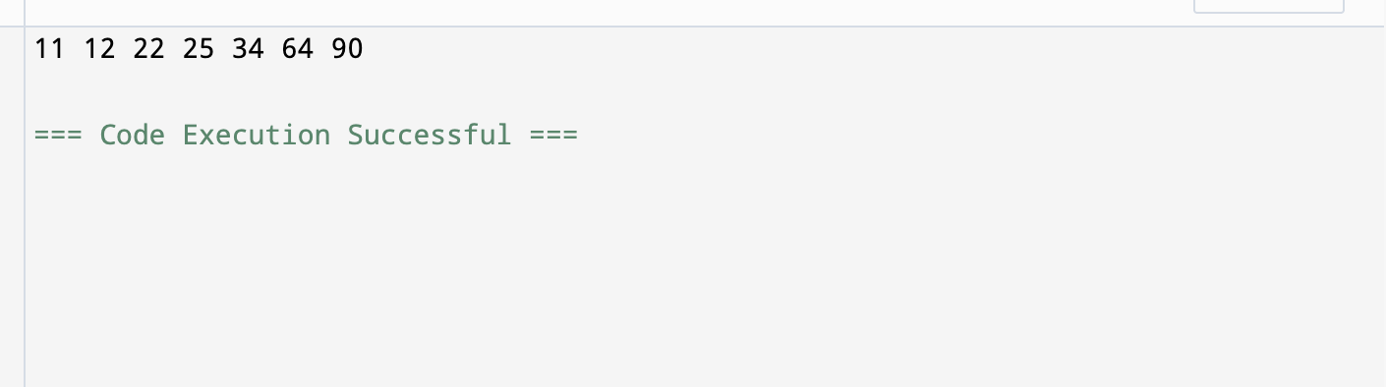

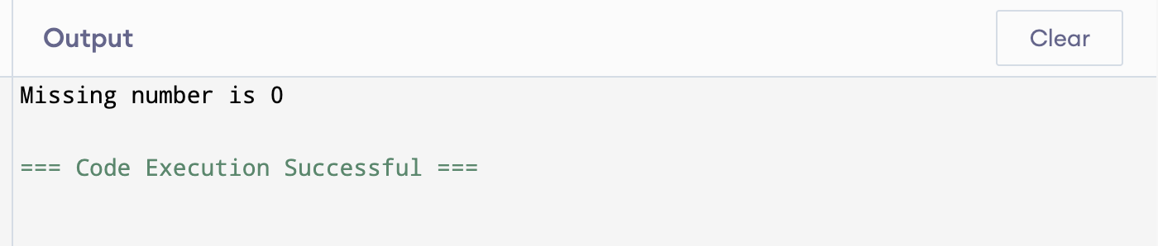

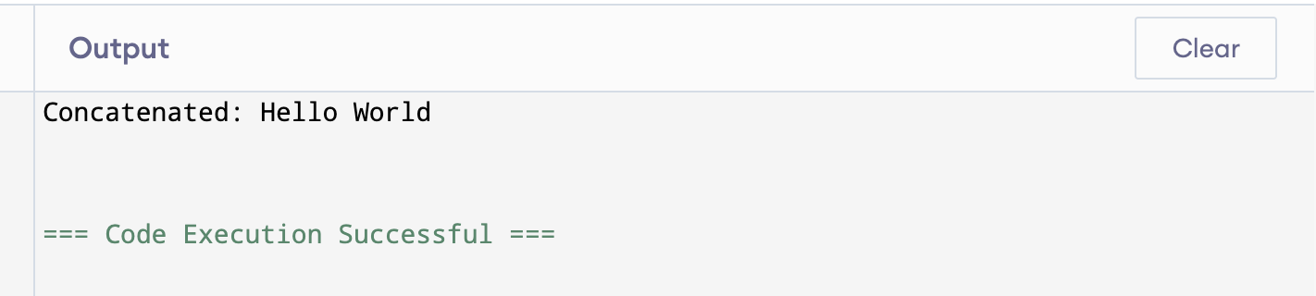

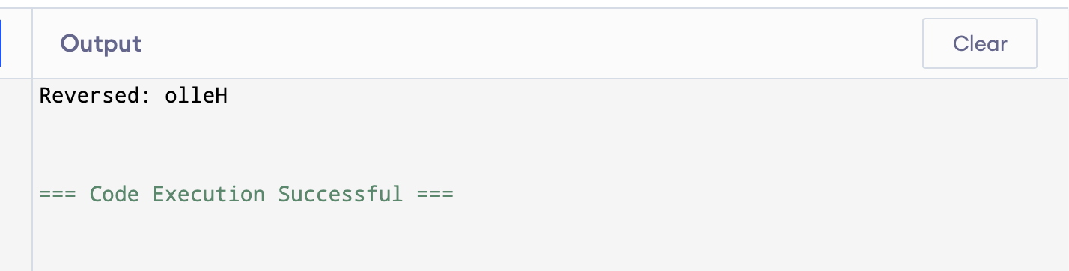

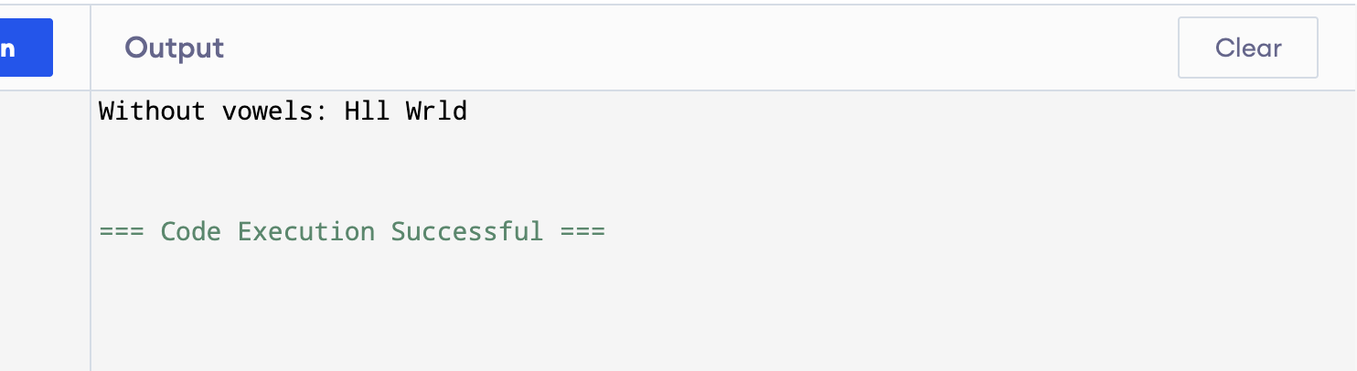

Question5
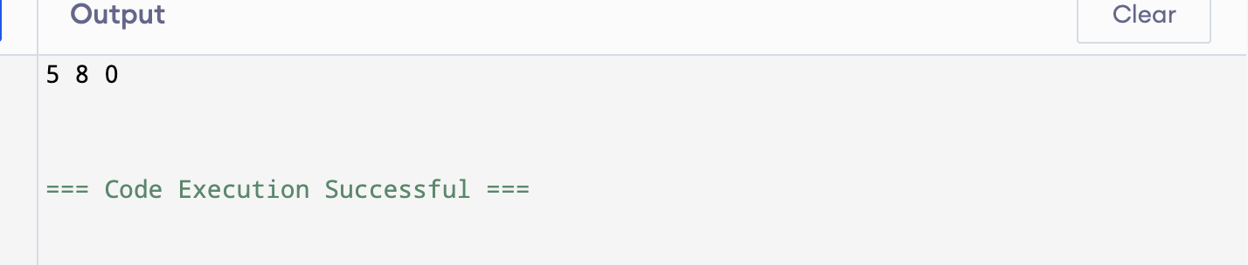

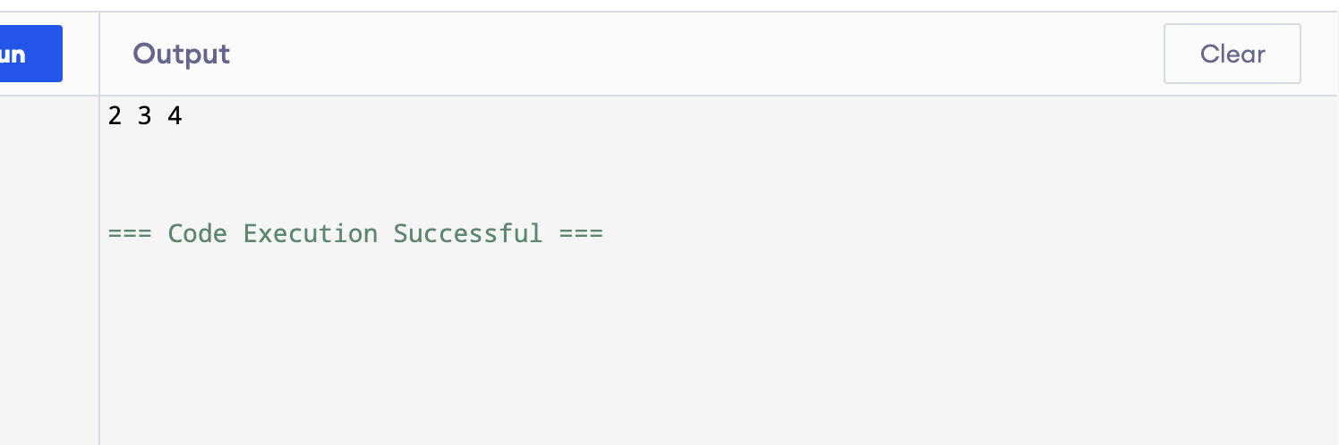

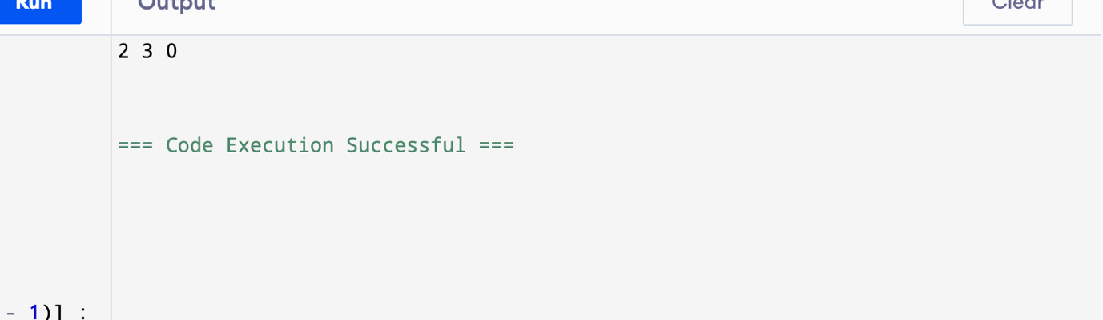

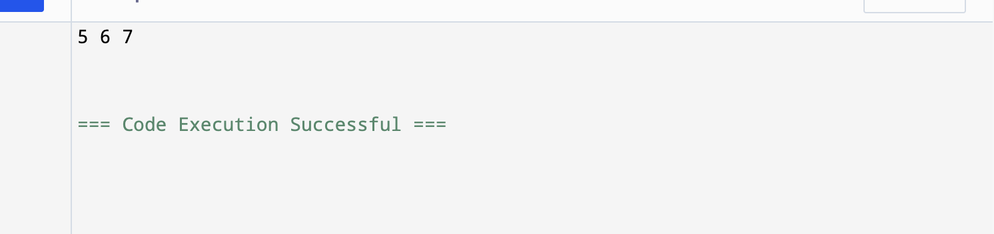

Question 6
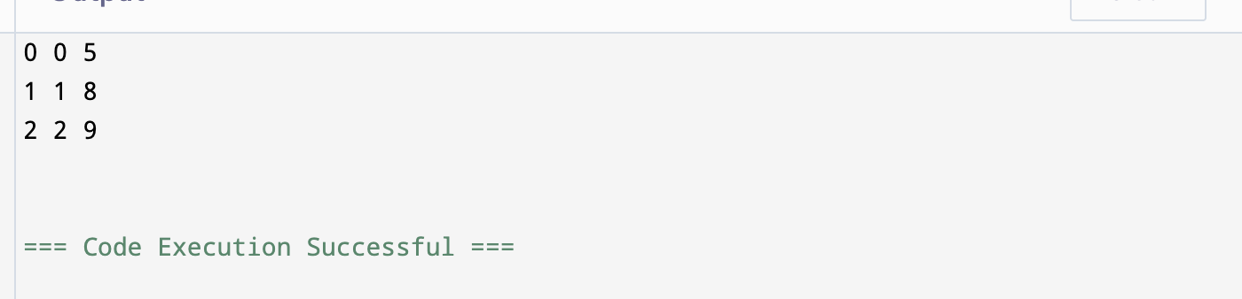

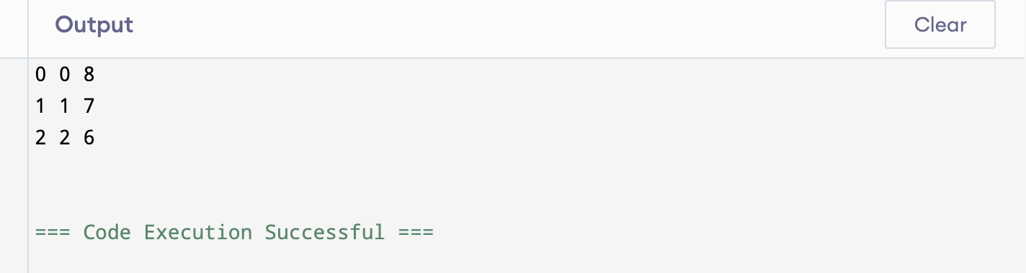

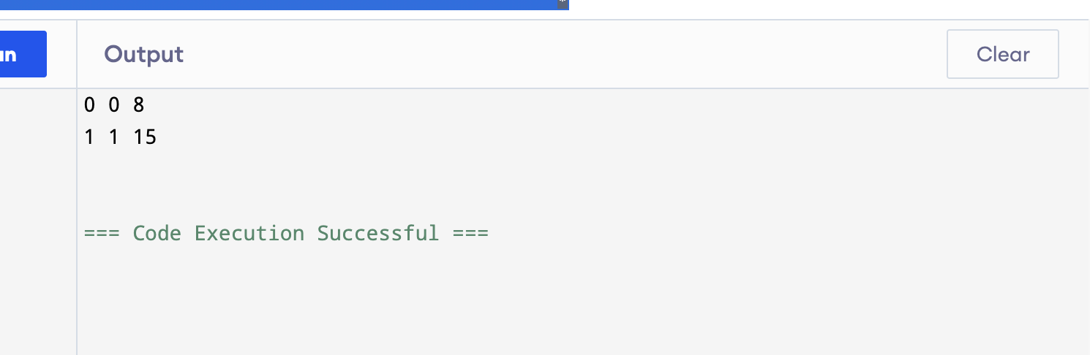

Question 7
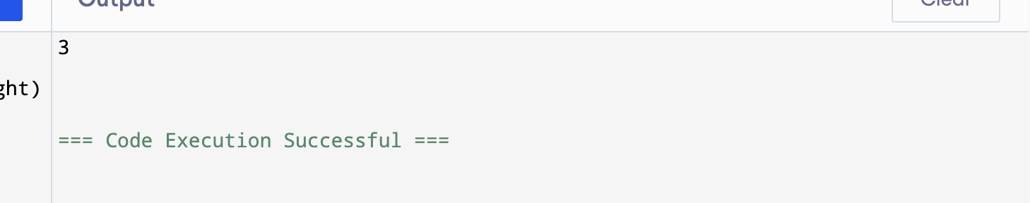

Question 8
